Nama : Monica Tifani Zahara
NRP : 171 111 077
HEURISTIK
- Binary tree
πNama

⋈Nim = Nim

πNim πNim, nama

⋈Kd_krs=kd_krs σtgl_masuk>2008

πKd_krs πNim, kd_krs
Tbl_mahasiswa

σNilai_huruf=’A’ tbl_krs
Tbl_krs

Tbl_krsdetail

- Join
SELECT tbl_mahasiswa.NAMA FROM tbl_krsdetail, tbl_krs, tbl_mahasiswa
WHERE tbl_krs.KD_KRS=tbl_krsdetail.KD_KRS
AND tbl_mahasiswa.NIM=tbl_krs.NIM
AND YEAR(tbl_mahasiswa.TGL_MASUK)>2008
AND tbl_krsdetail.NILAI_HURUF='A'
GROUP BY tbl_mahasiswa.NAMA

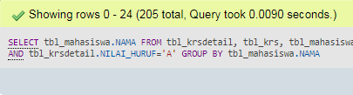

- Subquery
SELECT tbl_mahasiswa.NAMA FROM tbl_mahasiswa
WHERE YEAR(tbl_mahasiswa.TGL_MASUK)>2008
AND tbl_mahasiswa.NIM IN (SELECT tbl_krs.NIM FROM tbl_krs WHERE
tbl_krs.KD_KRS IN (SELECT tbl_krsdetail.KD_KRS FROM tbl_krsdetail WHERE tbl_krsdetail.NILAI_HURUF='A')) GROUP BY tbl_mahasiswa.NAMA

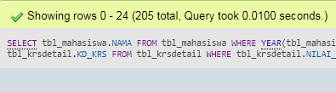

- Binary Tree
πNama

⋈Nim = Nim

πNim πNim, nama

⋈Kd_krs=kd_krs
Tbl_mahasiswa

πKd_krs πNim, kd_krs

⋈Kdmk=kdmk σ semester=1

πKd_krs πKd_krs, kdmk
Tbl_krs

σ nama_mk
= ‘PEMROGRAMAN PASCAL’
Tbl_krsdetail

Tbl_matakuliah

- Join
SELECT tbl_mahasiswa.NAMA FROM tbl_mahasiswa, tbl_krs, tbl_krsdetail, tbl_matakuliah
WHERE tbl_krs.KD_KRS=tbl_krsdetail.KD_KRS
AND tbl_mahasiswa.NIM=tbl_krs.NIM
AND tbl_matakuliah.KDMK=tbl_krsdetail.KDMK
AND tbl_matakuliah.NAMA_MK='PEMROGRAMAN PASCAL'
AND tbl_krs.SEMESTER=1
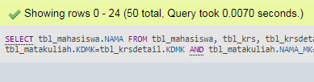

- Subquery
SELECT tbl_mahasiswa.NAMA FROM tbl_mahasiswa WHERE tbl_mahasiswa.NIM IN
(SELECT tbl_krs.NIM FROM tbl_krs, tbl_krsdetail WHERE tbl_krsdetail.KD_KRS=tbl_krs.KD_KRS AND tbl_krs.SEMESTER=1 AND tbl_krsdetail.KDMK IN
(SELECT tbl_matakuliah.KDMK FROM tbl_matakuliah WHERE tbl_matakuliah.NAMA_MK='PEMROGRAMAN PASCAL'))
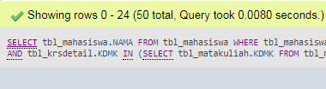

- Binary Tree
πnama_dosen

⋈kd_dosen = kd_dosen

Πkd_mk πkd_dosen, nama_dosen

⋈Kd_mk=kd_mk
Tbl_dosen

πKd_mk πkd_mk

Tbl_krsdetail

σnama_mk=”PEMROGRAMAN PASCAL”

Tbl_matakuliah

- Join
SELECT tbl_dosen.NAMA_DOSEN FROM tbl_dosen, tbl_krsdetail, tbl_matakuliah
WHERE tbl_dosen.KD_DOSEN=tbl_krsdetail.KD_DOSEN
AND tbl_matakuliah.KDMK=tbl_krsdetail.KDMK
AND tbl_matakuliah.NAMA_MK='PEMROGRAMAN PASCAL' GROUP BY tbl_dosen.NAMA_DOSEN
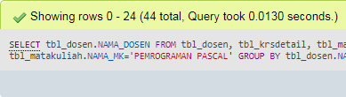

- Subquery
SELECT tbl_dosen.NAMA_DOSEN FROM tbl_dosen WHERE tbl_dosen.KD_DOSEN IN(
SELECT tbl_krsdetail.KD_DOSEN FROM tbl_krsdetail WHERE tbl_krsdetail.KDMK IN(
SELECT tbl_matakuliah.KDMK FROM tbl_matakuliah WHERE tbl_matakuliah.NAMA_MK='PEMROGRAMAN PASCAL')) GROUP BY tbl_dosen.NAMA_DOSEN
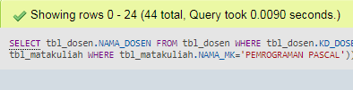

- Binary Tree
πnama

⋈nim=nim

σnim = null πnim, nama

Tbl_mahasiswa

Tbl_krs

- Join
SELECT tbl_mahasiswa.NAMA FROM tbl_krs
RIGHT JOIN tbl_mahasiswa ON tbl_mahasiswa.NIM=tbl_krs.NIM
WHERE tbl_krs.NIM IS NULL
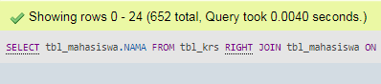

- Subquery
SELECT tbl_mahasiswa.NAMA FROM tbl_mahasiswa WHERE tbl_mahasiswa.NIM NOT IN (
SELECT tbl_krs.NIM FROM tbl_krs)
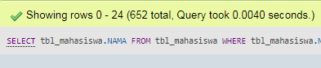

- Binary Tree
Πnama, AVG(nilai_angka)

⋈nim=nim

Πnim πnim, nama

⋈Kd_krs=kd_krs
Tbl_mahasiswa

Πkd_krs, AVG(nilai_angka) πkd_krs, nim

σnama_mk=”PEMROGRAMAN PASCAL” σnim=nim

Tbl_krs

- s
Tbl_krsdetail

- Join
SELECT tbl_mahasiswa.NAMA, AVG(tbl_krsdetail.NILAI_ANGKA) AS AVERAGE FROM tbl_mahasiswa, tbl_krs, tbl_krsdetail
WHERE tbl_krs.KD_KRS=tbl_krsdetail.KD_KRS
AND tbl_mahasiswa.NIM=tbl_krs.NIM
GROUP BY tbl_mahasiswa.NAMA

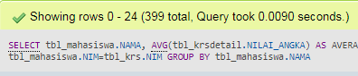

- Subquery
SELECT tbl_mahasiswa.NAMA, AVG(tbl_krsdetail.NILAI_ANGKA) AS AVERAGE FROM tbl_mahasiswa, tbl_krsdetail WHERE tbl_krsdetail.KD_KRS IN ( SELECT tbl_krs.KD_KRS FROM tbl_krs WHERE tbl_krs.NIM=tbl_mahasiswa.NIM) GROUP BY tbl_mahasiswa.NAMA
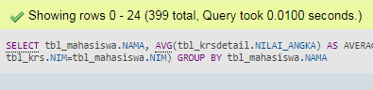

- Binary Tree
Πnama

⋈nim=nim

Πnim πnim, nama

⋈Kd_krs=kd_krs
Tbl_mahasiswa

Πkd_krs πkd_krs, nim

⋈Kd_kosen=kd_dosen σsemester=3

Tbl_krs

Πkd_krs, kd_dosen Πkd_dosen

Tbl_krsdetail

Πnama_dosen=”SUGENG HARIYANTO”

Tbl_krs

- Join
SELECT tbl_mahasiswa.NAMA FROM tbl_mahasiswa, tbl_dosen, tbl_krsdetail, tbl_krs
WHERE tbl_krs.KD_KRS=tbl_krsdetail.KD_KRS
AND tbl_mahasiswa.NIM=tbl_krs.NIM
AND tbl_dosen.KD_DOSEN=tbl_krsdetail.KD_DOSEN
AND tbl_dosen.NAMA_DOSEN='SUGENG HARIYANTO'
AND tbl_krs.SEMESTER=3

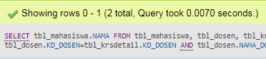

- Subquery
SELECT tbl_mahasiswa.NAMA FROM tbl_mahasiswa WHERE tbl_mahasiswa.NIM IN(
SELECT tbl_krs.NIM FROM tbl_krs WHERE tbl_krs.SEMESTER=3 AND tbl_krs.KD_KRS IN(
SELECT tbl_krsdetail.KD_KRS FROM tbl_krsdetail WHERE tbl_krsdetail.KD_DOSEN IN (
SELECT tbl_dosen.KD_DOSEN FROM tbl_dosen WHERE tbl_dosen.NAMA_DOSEN='SUGENG HARIYANTO')))

